**Prerequisites of a Spark Application**

1.  Spark applications should be consuming the Spark Operator and not the KubeDirector Spark application as per the Product team ‘s recommendation. [Ref](https://docs.containerplatform.hpe.com/52/reference/kubernetes-applications/spark/Spark_Operator.html?hl=spark)

2. Sidecar inejction must be disabled for any tenant using spark application

* If the pods of a spark tenant are stuck in **Init:CrashLoopBackOff** error or **OOMKilled** (Out Of Memory Killed) error, do

**kubectl get ns <namespace> --show-labels**  


* If we see that **istio-injection** is **enabled,** then do



We can get **hpecp-tenant-86** from the labels section of 1st screenshot where hpecptenant=hpecp-tenant-86

* Edit the configuration and set **enableServiceMesh** from **true** to **false**.

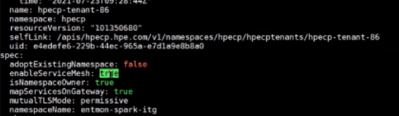

Save the file

* Check if *istio-injection=disabled*

**kubectl get ns <namespace> --show-labels**



* Ask the application team to scale their pods down and then up for the pods to come up without sidecar.